|  |
| --- |
| **YEAR 12 Essentials Mathematics**  **Semester 2 2018**  **Test 7 – Arc Length & Time Zones** |
| Total Marks: ______ / 42 marks  Name: ______________________ Total Time: 55 minutes |

***Full working out must be shown to get full marks.***

***Attempt all questions***

***Resources allowed:***

***1 A4 page, (1 side) of hand written notes, ruler, calculator***

1. Use the map of the world to answer the following questions: (6 marks)

**B**

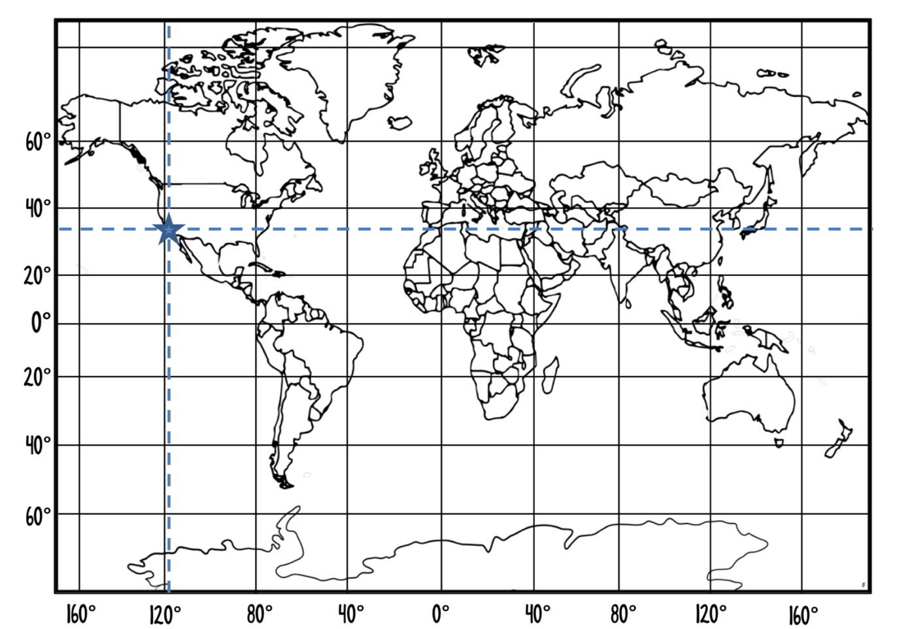

**A**

1. Name the significant line labeled A.__________________________________
2. Name the significant line labeled at B.________________________________
3. Los Angeles is located on the map with a star. What are the coordinates of Los Angeles? ____________________________________________
4. South Africa is located on the map with a circle. What are the approximate coordinates of South Africa? ____________________________________________
5. Calculate the arc length (shown in bold) in the following circles (Answer in cm) (5 marks)
6. (b)

|  |  |
| --- | --- |
|  |  |

1. Find the **arc angle** between Bali (5°S 115°E) and Mandurah (35°S 115°E) correct to the nearest degree. (2 Mark)
2. Find the **arc angle** between the points on Earth with coordinates of (12°N, 12°W) and (38°S*,* 12 °W). (2 Mark)
3. *A* (23°N, 121°W) and *B* (65°N, 121°W) are two points on the surface of the Earth. Find the distance to the nearest kilometer between the points *A* and *B.*

(Approximate the radius of the Earth as 6 400km) (3 Marks)

1. Find the distance between Stockholm (59°N 18° E) and Cape Town (34°S 18°E) correct to the nearest kilometer.

(Approximate the radius of the Earth as 6 400 km) (3 Marks)

1. Using the Time Zones table below answer the following questions (2 Marks)

|  |  |
| --- | --- |
| **City** | **Time** |
| Sydney | GMT+10 |
| Melbourne | GMT+10 |
| Adelaide | GMT+9:30 |
| Perth | GMT+8 |
| Darwin | GMT+9:30 |
| Brisbane | GMT+10 |
| Hobart | GMT+10 |

* 1. If it is 3: 51 PM in Sydney, what time would it be in Darwin?

* 1. If it is 11:45 pm in Perth, what time would it be in Melbourne?

1. If the time in Bangkok (GMT + 7) is 4:30am what time is it in Beirut (GMT +3)? (2 mark)

1. In the following map, the countries are defined by their time zone band, with their time relative to GMT given at the bottom of the band. (7 Marks)

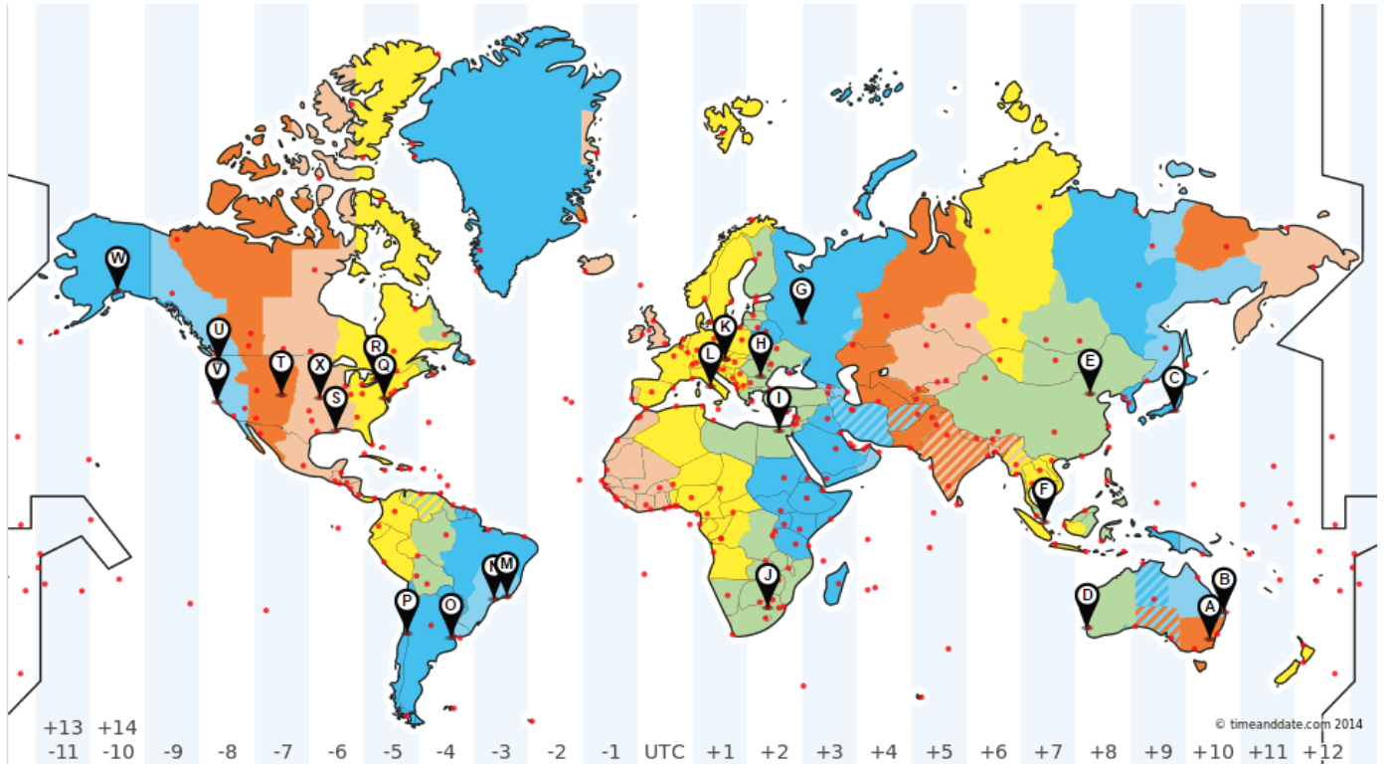

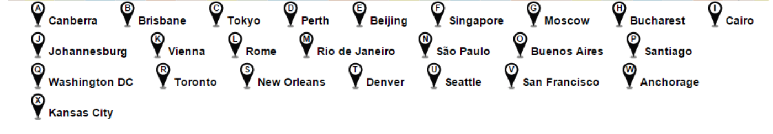

a). What is the time difference between Rome(L) and Rio De Janeiro(M)?

b). If it is 5 am on Tuesday in Beijing(E). What day and time is it in Johannesburg(J)?

c). We are starting the school day on Monday at 8:30am in Perth(D). What day and time would it be in San Francisco (V)?

d) A new movie is to be released at the same time all around the world. If the movie is released at midnight in Seattle (U). At what time will it be released in Johannesburg (J) and Tokyo (C)?

1. Han, who is in Canberra (GMT +10) at the moment, has an interview over Skype with the human resources manager of an American trading firm scheduled for 3 pm on Monday, New York (GMT -5) time. (3 Marks)
2. Calculate the time difference between the two cities.
3. Hence find the time in Canberra when it is 3pm on Monday in New York.
4. What day will the interview fall on in Canberra?
5. The table shows the time of several locations relative to GMT. (5 Marks)
6. Using the table, which location is ahead of the other in time?

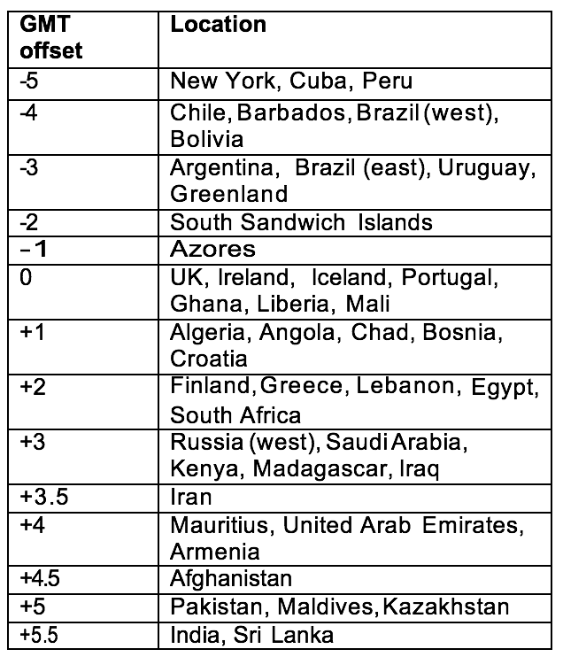

Cuba or Brazil (west)

1. What is the time difference between Cuba and Brazil (west)?
2. When it is 7 pm on the 11th of April in Brazil (west), what time and date is it in India?
3. What is the time difference between Pakistan and Egypt?
4. What is the time approximate difference between two cities that have a 150 difference in longitude? (2 marks)

END OF TEST